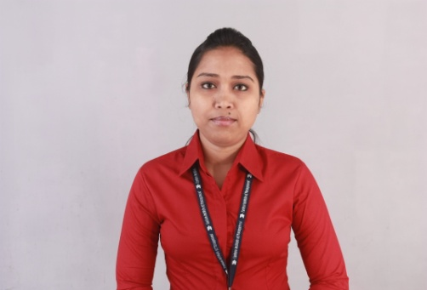

Your passport size photo (scanned)

**Paromita Pal**

**Address:** Address: 233/2A, A.P.C Rd, Shyambazar

Pin: 700 004

**Contact no:** **9732049500/9734115547**

**Email ID:** [**paromitapal77@gmail.com**](mailto:paromitapal77@gmail.com)

**OBJECTIVE: To make a positive impact in my field of activity leading to Organization growth by creative application of my value based convictions and professional divinity by putting my all efforts in the work assigned to me in an organization where I can grow along with the Organization.**

**ACADEMIC QUALIFICATION**

|  |  |  |  |  |
| --- | --- | --- | --- | --- |
| **Degree** | **Institution** | **Board/University** | **Marks (%)** | **Year of passing** |
| MBA  (Marketing) | Eastern Institute of Management | University of Kalyani | 61.10 | 2015 |
| B.A | Raj Collage | University of Burdwan | 47.25 | 2012 |
| XII(10+2) | Bidyarthi Bhavan Girls High School | W.B.C.H.S.E | 62.08 | 2009 |
| X(10) | Bidyarthi Bhavan Girls High School | W.B.B.S.E | 69.63 | 2007 |

**Computer Proficiency:** Operating Systems: Microsoft windows XP, Windows Vista, 2007. Languages: C, C++.Packages: MS-Office, MS-Dos, Tally 7.2 & Internet etc.

**WORK EXPOSURE:**

* **Currently worked at “BHARTI AIRTEL Ltd” as a Store In-charge.**
* **Working as a Sales Executive Officer for 1 year in “ASMITHA MICROFINANCE LTD” at Durgapur.**
* **Achieves highest ranking in Marketing & Sales survey Project for Schaeffler India “Schaeffler India Business Research- Taxi Segment”.**
* **I have attended a preventive awareness for General health and Hygiene Course from Government of West Bengal.**

**SUMMER TRAINING**

**Project topic: “Study of DHFL’s Home Loan”**

**Organization:** Dewan Housing Finance Corporation Ltd ;( **DHFL, Durgapur Branch**)

**Duration:** June - August (2014)

**Brief Description:** Conducted a marketing study to understanding the following awareness about company’s product, Usage profile of D.H.F.L product among existing customer, product knowledge of sales person. The activities is undertaken to improve awareness & Comparison to D.H.F.L with other competitors.

**PERSONAL DETAILS**

Date of Birth: 17th April 1991

Gender: Female

Marital Status: Single

Languages Known: English, Bengali, and Hindi.

Hobbies: Dancing, Sports (kabadi, swimming, exercise), Volunteer work

**STRENGTH**

**Effective communicator and listener**

**Accuracy and punctuality**

**Desire and ability to solve problems**

**Team player, Energetic and Goal driven**

**A “work hard, play hard” approach**

**REFERENCE**

Mr. Kumar Amit Prof. Arun Kumar Dey

Vice President (Mid-Corporate Group) Prof. of Finance

STATE BANK OF INDIA (Regional Office- Kolkata) Eastern Institute of Management

Mob- 9330579588 Mob- 033-66338640

**DECLARATION**

I hereby declare that the above given information are true and to the best of my knowledge.

Date: Yours sincerely,

Place: Paromita Pal